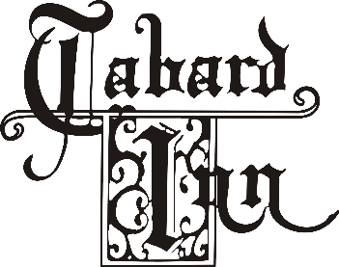
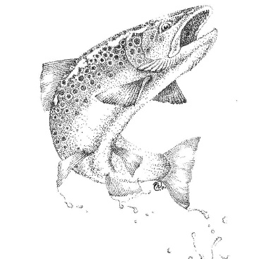

LUNCH
Available Monday-Friday from 11:00 am until 3:00 pm
Starters
Tabard Donut - whipped cream $2 each
Oat Scone - seasonal preserve $4 each
Deviled Eggs - pickled plum, crispy shallot $12
Caramelized Onion Tart - goat cheese $14
Hush Puppies - honey butter, cayenne pepper, chives $15
Sunchoke Soup – sunchoke salad, sunchoke cracker $16
Mushroom Toast - mushroom duxelles, cultured crème fraiche, sourdough toast points $17
Whipped Bone Marrow - roasted bone marrow spread, pickled shallots, country herbs, sourdough $19
Half Dozen Chesapeake Oysters - cocktail sauce, seasonal mignonette, lemon $23

Salads
add fried or grilled chicken $10/add grilled shrimp $15/add 6oz salmon $18
add poached egg $4/add anchovies $5 / add Maryland crabcake $20 / add 6oz skirt steak $22

Caesar - romaine, potato crunch, aged sheep cheese $17
Frisée - shallots, apples, hazelnuts, crispy Benton’s bacon, Dijon mustard vinaigrette $17
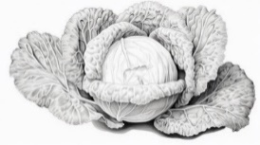
Grain Bowl - farro, lolla rossa, frisee, pickled French breakfast radish, pea shoots, green goddess $17

Sandwiches
Avocado and Crab Toast - sunny side up egg, buckwheat, little salad $24
Chicken Sandwich - sorghum glaze, pickled green tomato, chili honey, broccoli slaw $17
Salmon Burger - brioche bun, homemade cocktail sauce, avocado $23
The Burger - double smashed beef, smoked onion cheese, buckwheat, cucumber pickles, garlic herb fries $23
add bacon +4, add fried egg +4

Entrees
Steak Frites - 6oz skirt steak, green peppercorn sauce, garlic herb fries $33
Pan-Seared Salmon - delicata squash, farro, mustard greens, cider beurre blanc $39
Shrimp & Grits - Anson Mills heirloom grits, pan-seared shrimp, smoked onion butter, lobster broth $28
Carolina Gold Rice - wild mushrooms, burrata, puffed wild rice $36



Sides

Garlic Herb Fries $6
Creamed Seasonal Vegetables $12
Broccoli Coleslaw $9
Carolina Gold Rice with Burrata 20

