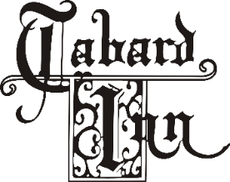
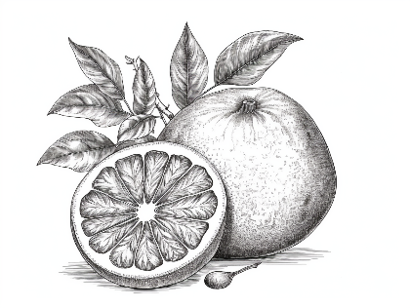

BRUNCH
Starters & Salads
Tabard Donut $2 each
Oat Scone $4 each
Sunchoke Soup - sunchoke salad, sunchoke cracker $16
Greek Yogurt - granola, mixed berries, cacao nibs, honey $12
Mushroom Toast - mushroom duxelles, cultured crème fraiche, sourdough toast points $17
Whipped Bone Marrow - roasted bone marrow spread, pickled shallots, country herbs, sourdough $19
Half Dz. Chesapeake Oysters – cocktail sauce, seasonal mignonette, lemon $23
Green Goddess Salad - romaine, pickled shallots, seeds, soft-boiled egg $16
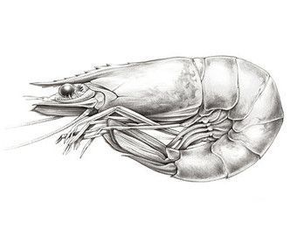
Caesar Salad - Oldwick shepherd cheese, potato crunch $17
Frisee Salad - Benton’s bacon, hazelnut, apples, bacon-mustard vinaigrette $17
Grain Bowl - farro, lolla rossa, frisee, pickled french breakfast radish, pea shoots, green goddess $17
add to any salad or bowl…
fried or grilled chicken $10/grilled shrimp $15/ 6oz salmon $18
poached egg $4/anchovies $5 / maryland crabcake $20 / 6oz skirt steak $22

Sandwiches
add fried egg $4 /bacon $5

Avocado and Crab Toast – sunny side up egg, buckwheat, little salad $24
Chicken Sandwich – sorghum glaze, pickled green tomato, chili honey, broccoli slaw, garlic herb fries $17
Breakfast Sandwich - egg any style, bacon or sausage, cheese, zhoug, english muffin, home fries $16
The Burger – double smashed beef, smoked onion cheese, buckwheat, cucumber pickles, garlic herb fries $23
add bacon +4, add fried egg +4

Entrees
Classic Eggs Benedict - poached eggs, hollandaise, home fries
country ham $21/lox $24 /maryland crabcakes $40
Steak & Eggs – 6oz skirt steak, two eggs (any style), home fries, hollandaise $35
Shrimp & Grits – anson mills heirloom grits, pan-seared shrimp, smoked onion butter, lobster broth $28
Tabard Omelette - fine herbes, smoked paprika sauce, home fries $16 add smoked trout roe +$12
Lox Scrambled Eggs - house-cured lox, cream cheese, capers, dill, red onion, home fries $17
Huevos Rancheros - crispy corn tortillas, sunny eggs, smoky tomato ancho sauce, charred scallion crema $22
Chicken and Waffle - sorghum, bacon, and coffee jam, breaded chicken, hot honey $25
Pancakes - powdered sugar, whipped butter, Pennsylvania maple syrup $15 add compote +$2, chocolate chips +$4
French Toast - seasonal compote, crème fraiche, Pennsylvania maple syrup $18
Tabard Breakfast - 2 eggs any style, home fries, bacon or sausage, biscuit or toast $18
substitute smoked cheddar grits for bread $3 / substitute chicken sausage +1
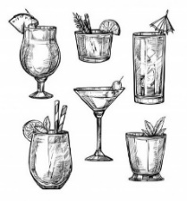
Sides $8
Breakfast Sausage ● Bacon ● Home Fries ● Smoked Cheddar Grits ● French Fries $6
Broccoli Coleslaw $9 ● Sauteed Kale $9 ● Chicken Sausage $9 ● Toast or Biscuits $4

Brunch Cocktails
available starting at 10:00 am
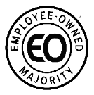
Peach Bellini 13  peach Cipriani,  Gioielli spumante | Mimosas for the Table 45  750ml Gioielli spumante and a carafe of OJ  single mimosa - 12 | Tabard Bloody Mary 14  Wheatley vodka,  house bloody mary mix, garnish
6.5

